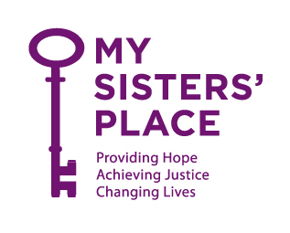

March 22, 2020
To Whom It May Concern:

This letter is to inform you that Ms. ___ is currently residing at a confidentially-located emergency shelter for victims of domestic violence in Westchester County operated by our agency, My Sisters’ Place, Inc. and licensed and funded by New York State and Westchester County government. Ms. ___was informed by her manager at ShopRite yesterday that a fellow employee with whom Ms. ____likely had contact has tested positive for COVID-19. Ms. ____has been experiencing symptoms that include a cough and shortness of breath.

Our emergency shelter is a congregate care setting that houses up to 20 adults and children of all ages, and employees approximately 15 staff who rotate in on shifts. While we have made arrangements to quarantine Ms. ____ we are of course concerned for the health and safety of not only Ms. ____, but the up to 35 individuals with whom Ms. ____has come into contact.

We respectfully request and urge you to provide a COVID-19 test to Ms. ____ today or as soon as possible.

Pursuant to New York State Governor Andrew Cuomo’s Executive Order 202.6, known as “New York on PAUSE” and in response to the current COVID-19 health crisis, employees of domestic violence organizations are considered “essential employees” who must be able to report to work. Specifically, our organization falls under the “Providers of Basic Necessities to Economically Disadvantaged Populations,” which includes “those operating community shelters and other critical human services agencies providing direct care or support.” As such, we must do what we can to protect our workforce so that they are healthy enough to continue coming to work to serve victims and survivors.

If you have any questions or concerns, please contact my Chief Program Officer, Amy Siniscalchi, XXXX.

Thank you, and be safe.

Karen Cheeks-Lomax, Esq.
Chief Executive Officer

